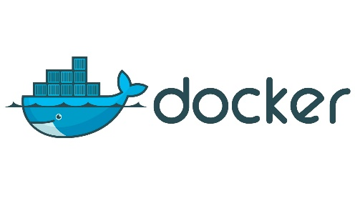 **Practical**

**Ways to create images**

1. **Take image from Docker Hub.**
2. **Create an image from existing container.**
3. **Create an image from Docker File.**

**EC2 Instance Details**

**Instance Name:** amazon linux ami

**Security Group Options:** ssh and http

**To update the server**

yum update -y

**To install docker**

yum install docker -y

**To check service is start/stop**

service docker status

docker info

**To Start Service**

service docker start

**To see all images**

docker images

**To find images in docker hub**

docker search (name)

**To download image on local machine from docker hub**

docker pull (name)

**To Run Container**

docker run -it Image ID or Image Name /bin/bash

**To create a container and give name to container**

docker run -it --name cloudnation ubuntu /bin/bash

(Here it stands for interactive mode and terminal)

**To start container**

docker start cloudnation

**To go inside container**

docker attach cloudnation

cat /etc/os-release

exit

**To see all containers**

docker ps -a

(here ps is process status and a for all)

**To see only running containers**

docker ps

**To stop container**

docker stop cloudnation

**To delete container**

docker rm cloudnation

**To delete the image**

docker rmi (image name)

**Create container from our own created image**

docker run -it --name cloudnation ubuntu /bin/bash

cd tmp

touch cloudnationfile

**For checking the updates in container**

docker diff cloudnation

**Now create an image of this container**

docker commit newcontainer ubuntuupdated

docker images

**Now create conatiner from the new image**

docker run -it --name cloudnationupdated ubuntuupdated /bin/bash

**Create an image and run container through docker file**

vi Dockerfile

FROM ubuntu

RUN echo "kattappa ko kisne maara” >> /tmp/bahubali

docker build -t testimage .

docker run -it --name cloudnation testimage /bin/bash

**Create volume and share it from container to container**

sudo su

yum update -y

yum install docker

service docker start

service docker status

touch file1 file2

vi Dockerfile

FROM ubuntu

VOLUME [“/myvolume”]

docker build -t myimage .

docker images

docker run -it --name container1 myimage /bin/bash

ls

cd myvolume

touch filex filey filez

ls

exit

docker run -it --name container2 --privileged=true --volumes-from container1 ubuntu /bin/bash

ls

cd myvolume

ls

exit

docker start container1

docker attach container1

ls

cd myvolume

ls

**Create volume by command**

docker run -it --name container 3 -v /volume2 ubuntu /bin/bash

ls

cd volume2

touch babadish

exit

docker run -it --name container4 --privileged=true --volumes-from container3 ubuntu /bin/bash

ls

cd volume2

ls

cd volume2

touch kuppa

exit

docker start container3

docker attach container3

ls

cd volume2

ls

**Create volume and share it from host to container**

pwd

cd /home/ec2-user

docker run -it --name hostcont -v /home/ec2-user:/cloudnation --privileged=true ubuntu /bin/bash

ls

cd cloudnation

ls

exit

docker start hostcont

docker attach hostcont

cd cloudnation

touch kullu khallas

exit

ls

**Create your own docker hub account**

**https://hub.docker.com/**

**Create our own image and push it to docker hub**

sudo su

yum update -y

yum install docker

service docker start

service docker status

docker run -it ubuntu /bin/bash

ls

touch abc xyz right wrong

ls

cd tmp

touch aabra daabra

exit

docker images

docker ps -a

docker commit stupefied_buck image1

docker images

docker login

username

password

docker tag image1 cloudnation123/ourdevops

docker push cloudnation123/ourdevops

**Login to new instance in new region and pull the image from docker hub**

sudo su

yum update -y

yum install docker

service docker start

service docker status

docker login

username

password

docker pull cloudnation123/ourdevops

docker images

docker run -it --name mycontainer cloudnation123/ourdevops /bin/bash

ls

**You can make your docker hub image private so that no one can access it**

docker login

username

password

docker pull cloudnation123/ourdevops